LQR

“some theory”

For the matrices Q and R to set for the LQR implementation, we’ve chosen the parameter such that the states would reach 0 as soon as possible and the Control system wouldn’t use too much control variable: the q >> r

Control at the Unstable Position

After some trials, changing the parameters q and r, with the real model, we’ve found the proper matrices:

[qθ=10 qθ_dot=1 qϕ=10 qϕ_dot=10] and [r=1] “fix this visualization lol”

The qs related to the states of the bar should be higher if we want them to reach the equilibrium quickly (ϕ=180° and ϕ_dot=0), instead the qs related to the states of the rod can be lower like q=1 and tis means they can move due to a perturbation and return to the equilibrium point slower than the bar, the important thing is that the bar is kept upside. What we notice when fixing the parameters is that the rod is not reaching the equilibrium point (at 0° position), maybe because while trying it the bar is not that steady, so the rod tries to reach new static position everytime and as a result the rod is not steady. To solve this solution we set the value for θ the same as for ϕ the .

For the Control Variable we initially set it to a very low value, r=0.01, since we wanted the qs much higher as we wanted the state to reach the equilibrium faster rather than penalizing the control variable. This, tho, causes the Control variable to be agressive (fast and high variation of the Voltage input), the response to a disturbance was very good tho, very fast to keep the bar at the vertical position. The problem was that the rod wasn’t steady, it was keeping to move either one side o the otherside depending on the perturbation on the bar. So as final value we choose for the Control variable is r=1.

In this phase of finding the proper values for the matrices we observed that:

* higher value for the qs causes a strong action, to solve this a higher value for r is needed
* the couple qs for each angle should not be that so differenti, even intuitively
* if you want the rod to not randomly walk and also hit the end stop, you should choose the same value as for the bar pendulum

As result we obtain the following verctor containing the gains: [-3.1623 -1.9351 -53.2574 -5.6413]

We expect that the Control system will be able to recover due to a perturbation in about 1.5s

“image of how the scheme should be, the statefeedback one”

Disturb on ϕ: impulse of 15° for about 0.05s

As we can see the recover time is a little bit less than 1.5s and we can appriciate that the bar pendulum is pretty steady even after the perturbation.

There is just this inverse response before just before the perturbation, but it not a big issue since the Control System has no problem dealing with it. This behavior is probably due to the presence of Positive zero. “ask the group what they think about this”

We can also appriciate that the rod is returns to 0° and not moving so much, the Control Variable (Input Voltage) is saturated only when the perturbation occurs and in the real model it is variating even after the perturbation, but not saturated as we.

This is the behavior we were expecting by setting the Q and R matrices in that way: fast recover and to not use that much control variable. So the simulation with the mathematical model is pretty much reliable with respect to the beahvior of the real physical model.

Robustness test: Parameter variation

* Ir = formula
* α = 0
* β = 0

The response is pretty much the same, this is because even if we have estimated the wrong values for the Rod Inertia or the damping coefficients, the performance is strongly affected by how we set the Matrices, what changes are the poles, but just small differences and in particular to high poles …”recover exactly what happens…”

Trajectory Tracking: sinusoidal signal of amplitude 45° and 0.05Hz of freqency.

When tracking a trajectory, usally, the corresponding parameters q are set higher than the others since we wanna put more importance on following the ref. Initially we set qθ=100, but this made the tracking to overcome the ref of 45°, it was higher, and with qθ_dot=10 the movement of the rod was a bit noisy.

Afert some trials we ended up choosing the following values for the matrices: [qθ=10 qθ_dot=10 qϕ=10 qϕ_dot=10] and [r=10] “fix this visualization lol”

Since we obsverved some conflict when starting the Control, in particular the Control system should keep the bar at the upside position and at the same time make the rod to follow the signal reference and as a result the bar was not that staedy, we decided to start the Control to keep the bar at vertical position and then starts the tracking. So we needed to use two slightly different matrices.

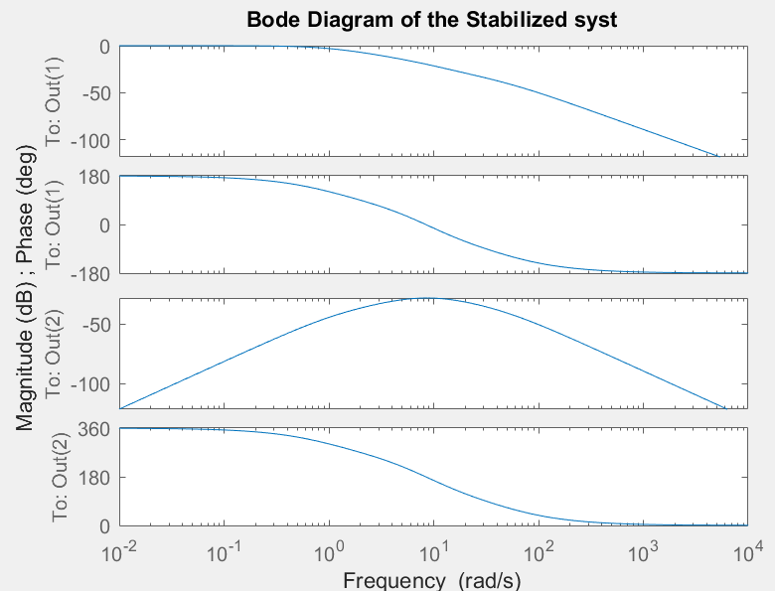“put the matrices for the track”

From the bode diagram we choose a frequency befor the cut-off frequency, or when the attentuation starts, at about 1 rad/s (0.159 Hz), so f=0.05 it’s a good choice.

The rod was following the reference very well, it was also getting close to the the variation of 45°. We could already see it with the simulation.

With f=1.1Hz we could observed the attenuation on the amplitude of the sinusoidal signal the rod was following: about 6°/7° with respect to the 45°, and with a higher one, f=10Hz, it was not oscillating at all.

Control at the stable Position

